**(19) Upper tropospheric Winds**

Upper Tropospheric winds:

1. Upper tropospheric winds are mirror opposite of surface winds and the vertical cell Hardley’s cell and Ferrel’s cells and polar cells they extended up to tropopause.
2. But in reality, the vertical cells are shallow. The vertical cell extends up to tropopause and upper tropopause conditions are diffident from the surface conditions.
3. The upper tropopause conditions are governed by different factors and forces.
4. At the tropopause the equator has high pressure while the pole has low pressure.
5. The pressure at upper troposphere at equator and poles are very strong as compared to pressure at subtropic and sub-polar regions.
6. Therefore, PGF is from the equator to poles. Therefore, the winds should move from equator to poles at upper troposphere. However, the wind Is affected by the Coriolis forces. (That upper tropospheric winds are free from the frictional forces.)
7. The Coriolis force depends on the speed of winds. The higher the speed, the higher the Coriolis force and higher the deflection.
8. In upper troposphere the winds are governed by the two forces and the Coriolis forces the balances the PGF and winds assumed a zero strophic balance and winds become westerlies in the nature.

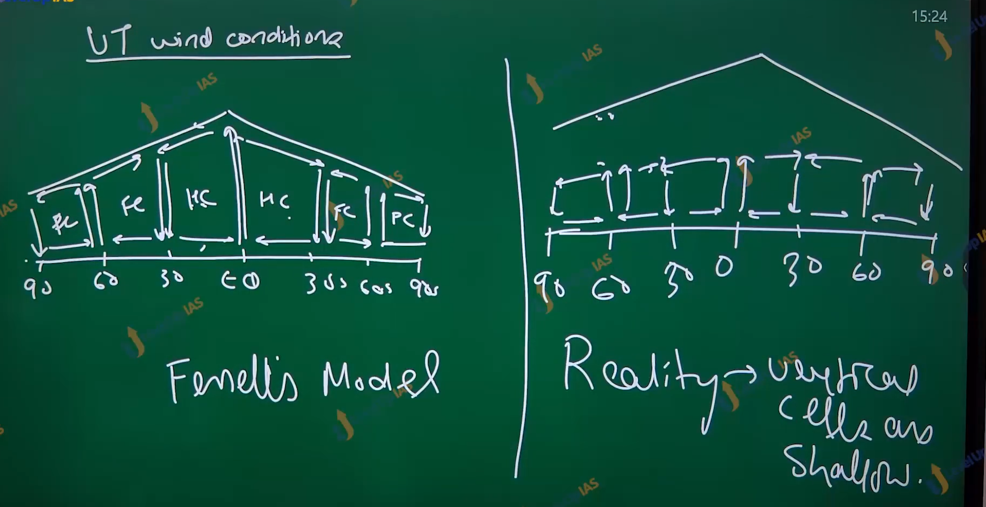

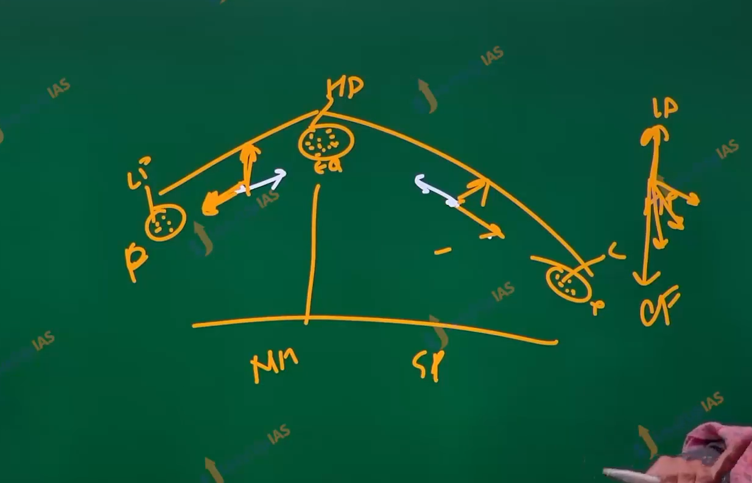

Some important points

1. Nearly all UT (upper tropospheric) winds are westerlies winds.
2. Nealy all the UT winds geostrophic winds (PGF is balanced by Coriolis force)

Rossby wave:

1. The upper tropospheric winds in the high latitudes beyond 55 degrees latitude towards pole experience the sharp meandering and called Rossby wave.
2. This Rossby wave induces additional high pressure and low pressure in the atmosphere.
3. These additional high-pressure, low-pressure cells in the upper atmosphere. induces the additional pressure cells on the surfaces. which influence the weather system on the surface
4. Beyond the 55 degrees latitude there is belt of forest which ever green temperate forest called taiga forest – boreal forest. In Britain Canada and Siberia.

Jet stream:

1. At the margins of vertical cells there is an additional pressure gradient which increases the velocity of upper tropospheric winds.
2. Such very high velocity winds are upper tropospheric winds at the margin on the vertical stream is called as jet stream.
3. The velocity of jet stream can be as high as 300 to 400 km per hour.
4. Jet steam is not sperate system but are embedded in upper tropospheric winds.
5. Jet streams are
   1. Very high velocity
   2. At margin of the vertical cells
   3. Embedded in the upper tropospheric winds
   4. Generally, they are westerlies winds.
   5. They are geostrophic winds.

Type of Jet steam:

1. Permanent jet stream
2. Temporary jet stream.

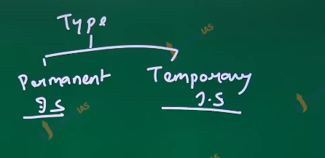

Permanent jet stream:

1. Subtropical westerlies jet stream:
   1. They are at 30 35 degrees latitude northern and south. That is they are at the margin of handle’s cells and Ferrel’s cells.
   2. They play important roles in the sudden bust of monsoon system in the India
   3. movement of the subtropical western jet steam is also responsible for the break in monsoon.
   4. Subtropical westerlies jet streams are also responsible for winter rains. That is western disturbance.
2. Polar jet streams:
   1. They are found at 60 65 degrees latitudes north and south. It is embedded in the Rossby wave.
   2. Like Rossby wave polar jet stream also follows a meandering part.
   3. The polar jet stream is associated with temperate cyclone.
3. Polar night jet stream:
   1. Found at poles it is seen only polar winter (polar night)
   2. This is a temporary jet stream.
4. It is a tropical easterlies jet stream.
   1. It was found at 15–20-degree latitude over south Asia.
   2. It is generally seen in the summer (march to oct to November) and late monsoon.
   3. It associated with summer Tibetan heating
   4. TEJ affects the south wests monsoon in the India

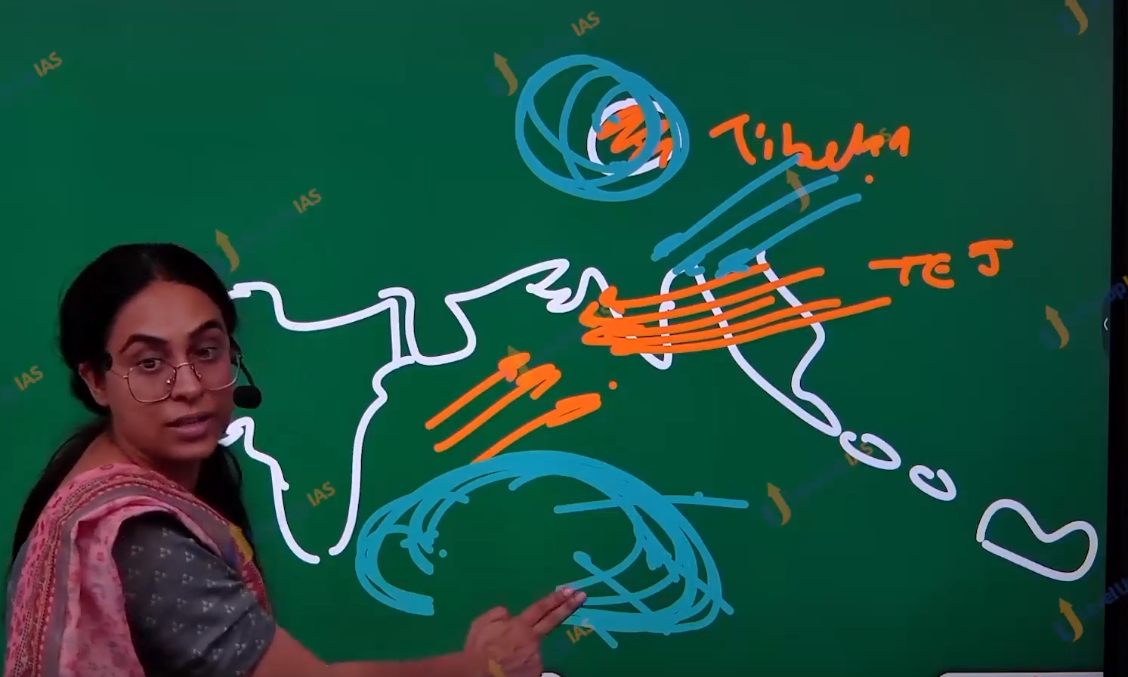

1. Somali jet stream: (also known as fiend later jet steam)
   1. It is a very unusual jet stream.
   2. It’s low-level jet steam. Seen at altitude at 2 to 2.5 km
   3. It is seen over the earthen Africa it plays important role in the strengthening the southwestern monsoon winds.

d